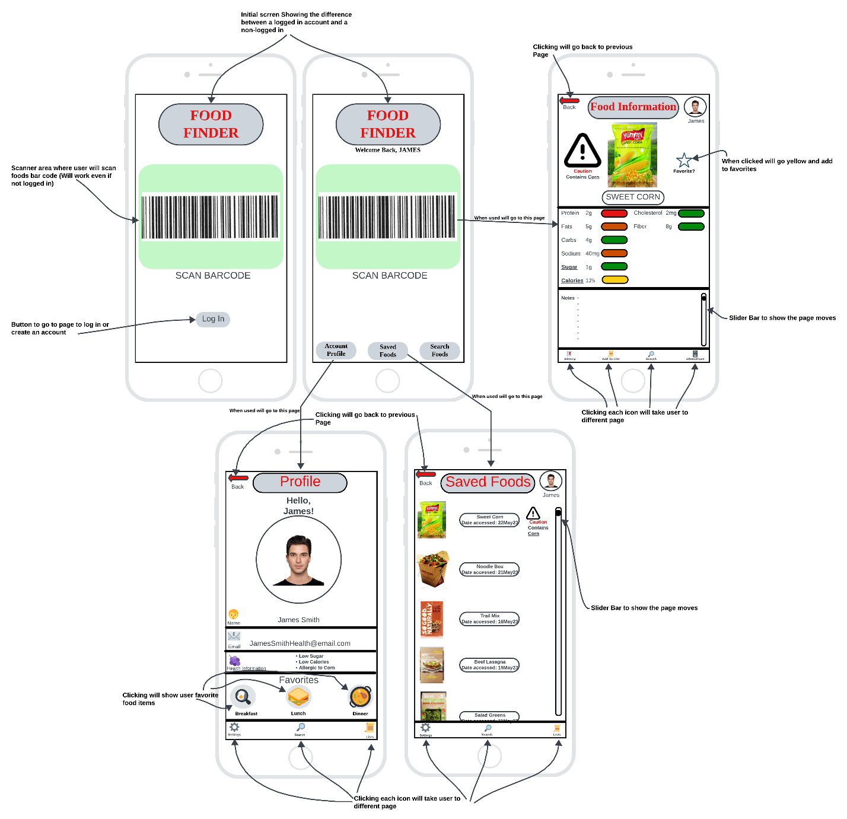Digital Wireframe

Wireframe Discussion

When looking at the wireframe example above we can see multiple pages that show what happens when the user uses the app. In the top left of the example there are two almost identical pages the page leftmost is the example page if there is no user signed in, they will have it options to sign in or scan foods but are limited to those options due to not having an account that can save information form other key functions of the app. The right most of the first page shows the options if there is a user signed in, they also have the option to scan right away, but also have option to go to account profile, saved foods, and search food which allows users to search food if the barcode isn’t working or they are thinking of a food, and they don’t have the barcode available. The page on the right goes over what happens when the user scans the food, it will pop up with an image of the food and the name, Due to the user being allergic to corn it will show a cation sign next to the food item. The user will also have an option to go back to the previous page and it shows their picture and name in the top right of the screen. Under that it will show the food health information as well as color code it based on health. Below is a note section going over ingredients, descriptions, and reasoning behind the color codes. There is also a slider that shows if there is more information on the page and allows the user to move up and down the page. Lastly, at the bottom they have the option to go to other important pages. On the bottom left is a profile page that has the option to go back to the previous page. Moving down the page the user has their image and some personnel information such as full name, email, and favorite food section which allows the user quickly find foods they have marked favorites and categorized based on when the user would most likely eat that food. At the bottom they again have more button options to access different pages of the app. On the saved foods page, it shows all the user previous scans and searches while again showing caution foods, it also gives them a button to go to the last screen and at the bottom they have a few more buttons for extra parts of the app.

This design benefits the user because it provides a simple yet effective way for them to figure out the foods they are shopping for. It also is customizable and takes in health considerations. This means the user will spend less time looking at details which in turn reduces the amount of time in the grocery store and helps them to know what food they are buying for the health and safety of both them and their family.

Different innovative solutions were put into place when developing this app. First, I simplified the pages to make it seem cleaner and easier to understand. Second, I put scroll wheels in place when there was more information than room to create a clean design that prevents extra tabs than needed. Next, I remembered sometimes technology doesn’t work so I added a search feature when the camera isn’t working properly which helps the user still get their goal completed. These solutions help to allow users to adapt to challenges as well as helping me figure out challenges with the design with the goal of having a clean and easy to use interface that accomplishes the user’s goals.

All this design came out this way due to previous research and input from perspective users. When I did something, I thought was good I got input from interviewees to confirm or deny those thoughts and then I would make changes. The initial design was thought out by doing research on what is proven and then implementing those design functions into my own design. This also included features and buttons to help keep the design simple and looking good at the same time.

As important as a phone is sometimes people forget their phone and need to use a smart watch as well. This design would be perfect to adapt to those changes. There will be limitations in place due to the smaller screen size, this means either less features or a lot more menus to fit those features in place as size is greatly reduced. There will also be the fact that smart watches don’t have cameras so the scanning options will not be possible. Overall, this means that a smart watch app would be more of an extension of the app rather than a replacement. It will be able to do a lot of the same features such as notes, profile, saved foods, etc. but will miss out on the scan feature and users will instead need to search for all the foods they are interested in. The app will still be target towards the same group of people focused on healthy foods, will be easy to use, and save time just not as much due to the user needing to type in foods rather than scan. This smart watch app will still be better than without an app as then the user needs to read the back of the products. How I will target this to my audience is ensure the app is still simple to use, looks good, saves time, and works effectively meeting the goals of my users.

Adapting this design to a touch-based kiosk bring sits own pros and cons. The pros would be it has a large screen so having all the features on a page or two would be easy. The other pro is the users wouldn’t need to have an app downloaded. The last pro would be that everyone in the store would be able to use this item. The cons on the other hand are user account would be almost impossible due to so many different people using it, but we could have the user input a code that sends the information to their phone. Another con would be the user would need to find the kiosk to scan their items which may be a hassle when there aren’t enough devices, or the device is on the other side of the store. The design of the device will be like the phone device but could support added features such as information transfer to user account via a code. The goals of the device will be the same with a target towards health and will show similar information as the other devices. Overall this device will be a great addition to the other devices and allows the user group who’s interested in health but may not have a device or forget there device to still use its great features.